Name: ______________________________________ Date: _____________________

**Algebra 1**



**Here’s how you can succeed in Math this year!**

1. Take detailed notes during class.
2. Do all of your homework. Show all of your work.
3. Stay organized.
4. Learn from your mistakes.
5. Find at least one “study buddy.”
6. If you are absent, be sure to catch up as soon as you can.
7. Ask questions during class.
8. Ask for help during Resource or Tigers i.
9. Never give up!

**Test-Taking Tips**

1. Don’t wait until the last minute to prepare!
2. Study using:
   * Your class notes and practice problems
   * Your online textbook
   * IXL
3. On the day of the test, do the problems you know well first.
4. When you finish the test, go back and check over your answers. Use SMILE to help!

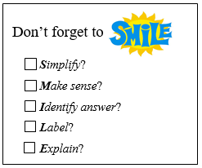

**Online Textbook Directions**

1. Go to Classlink. (https://myapps.classlink.com/home)



1. Click on the ConnectEd icon.
2. Click on Glencoe Math Accelerated 2017.



1. To access the actual textbook, click the eBook icon.

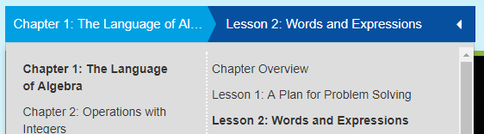

1. OR, on the Home page, choose the chapter and lesson.

1. To locate practice problems, video examples, and extra worksheets:



Click the menu button, and then Resources.

 **IXL Directions**

1. Go to [www.ixl.com](http://www.ixl.com)



1. Sign in at the top.
2. Look for the **yellow star** to see my Recommendations.

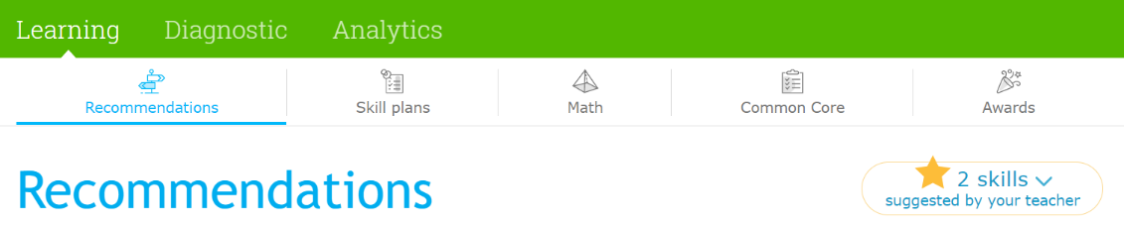

1. Alternately, you can use **Skill Plans** to find topics that match up with our textbook lessons.

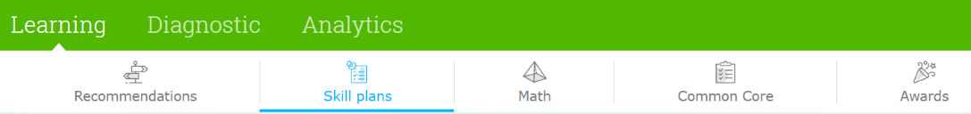

1. **Aim for a SmartScore of at least 80!**